Distribution of uranium, thorium and potassium in the Bayer process
A. Goronovski¹, J. Vind^{2, 3}, V. Vassiliadou², D. Panias³, A. H. Tkaczyk¹
¹ Institute of Physics, University of Tartu, W. Ostwaldi 1, 50411 Tartu, Estonia
² Aluminium of Greece plant, Metallurgy Business Unit, Mytilineos S.A., Agios Nikolaos, Boeotia, Greece
³ School of Mining and Metallurgical Engineering, National Technical University of Athens, Athens, Greece
Corresponding author: Andrei Goronovski, e-mail: goronovski@gmail.com

Abstract
Uranium, thorium, potassium and their decay product mass flows were analysed in the Bayer process. Gamma-ray spectroscopy was used to measure the radionuclide content in samples provided by Aluminium of Greece and to model their mass flows. We observed that at any analysed stage, the radionuclide content does not exceed the allowed safety limits set in the European Basic Safety Standard. Another important observation is that a minor portion of uranium from bauxites (3%) ends up in alumina, while the rest is accumulated in the bauxite residue (BR). All of the ²²⁶Ra (long-lived decay product of uranium), as well as all decay products of thorium accumulated in the BR. We observed accumulation of ⁴⁰K in the process liquors, while this radionuclide was not found in the alumina.

Introduction
The Bayer process is an industrial method used to refine alumina from bauxite by dissolution of the aluminium containing species in sodium hydroxide, separation of the remaining residue to give a supersaturated solution of sodium aluminate from which aluminium hydroxide is precipitated¹. Aluminium of Greece currently exploits karst (also known as diasporic) bauxites from the Parnassos-Ghiona deposit in Central Greece and minor amounts of karst bauxite from Turkey (Mersin mountains and Milas area). One fifth of the bauxite feed is lateritic (also known as gibbsitic) bauxite from Brazil (Trombetas).
After extraction of aluminum hydroxide, insoluble fractions of bauxite ore as well as secondary materials are accumulated in the by-product, Bauxite Residue (BR), including natural radionuclides (⁴⁰K, ²³²Th, ²³⁸U and their decay products) that appear in feed bauxites. In the current study, a comprehensive radionuclide mass balance through the entire Bayer process was performed to (1) establish relations between input and output radionuclide concentrations in the Bayer process so that it can be designed taking into account radiological considerations; (2) obtain comprehensive radionuclide mass balance knowledge within the Bayer process; and (3) aid prospective BR utilisation flowsheets in predicting the behaviour of radionuclides starting from bauxite to various final products within the Bayer process.

Methodology
Gamma-ray spectroscopy was used to define radionuclide concentrations in the Bayer process chain. ⁴⁰K, ²³⁸U, ²²⁶Ra (decay product of ²³⁸U), ²²⁸Ra and ²²⁸Th (decay products of ²³²Th) were studied. We selected several long-lived radionuclides with different chemical properties from a single decay chain to track possible distortions in the decay equilibrium. The samples have been kept intact for at least 6 months after preparation in order for decay products to reach secular equilibrium with the mother nuclides (i.e. we use ²³⁴Th to measure ²³⁸U).
We cannot measure the primordial isotope ²³²Th directly by gamma-ray spectroscopy, but its decay product ²²⁸Th provides a good proxy of the parent nuclide, as both are isotopes from the same chemical element. Measurement results were used to build a radionuclide mass-flow throughout the Bayer process, considering process data provided by the plant. Mass flow data of a one-day period was used.
A high purity germanium detector of broad energy type supplied by Canberra Industries® was used for measurements and an efficiency transfer computer model EFFTRAN² was applied to correct for differences in sample densities and matrices.

Sampling
Solid and liquid samples from process input, output and intermediate stages were collected during a 3-day period to represent a timely snapshot of all the materials interacting in the process.

Results
Complete radionuclide mass balance through the Bayer process is presented in Figures 1 – 5. Results are presented in the units of [Bq/kg] normalised over the mass of output calcined alumina:

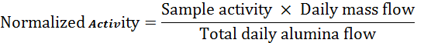 $Normalised activity=\frac{Sample activity ×Daily mass flow}{Total daily alumina flow}$ (1)

Bayer process mass-flow
In figures 1 – 5, the mass balances of every analysed isotope are summarised. In the blue boxes activity concentration of feed materials is presented, orange boxes correspond to measurements of process liquors, while red and green boxes stand for output materials. Solid material flow is denoted with black arrows while liquid with red. Dashed arrow stands for slurry. Finally, in the upper right corner radionuclide enrichment ratio in the BR is provided. Bauxite to BR ratio is calculated to be 2.4 based on the daily mass-flow.
²³⁸U, measured by its decay product ²³⁴Th, is presented in Figure 1. There is dissolution of uranium in the process liquors. However, most of the uranium still ends up in BR, while only minor portion, 3% of the initial amount ends up in alumina. In the hydrated alumina 4 Bq/kg ²³⁸U (please note that this is measured sample activity, not normalised as presented in the Figure 1) was measured, which is equivalent to 0.32 mg/kg uranium. It is in agreement with values published in the literature for uranium in aluminium hydroxide (0.3 – 0.5 mg/kg)^{3, 4} After calcination, 5 Bq/kg of ²³⁸U was measured in calcined alumina, which corresponded to ~0.4 mg/kg.

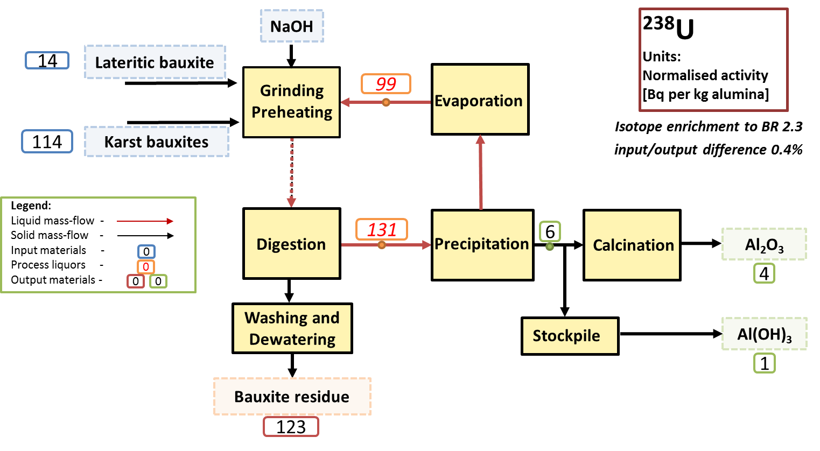
Figure 1: ²³⁸U mass flow through the Bayer process.
²²⁶Ra (decay product of ²³⁸U) is presented in Figure 2. Contrary to uranium, this radionuclide is not dissolved in the process liquors as well as it was not found in the hydrated or calcined alumina. All of this radionuclide ended up in the BR.

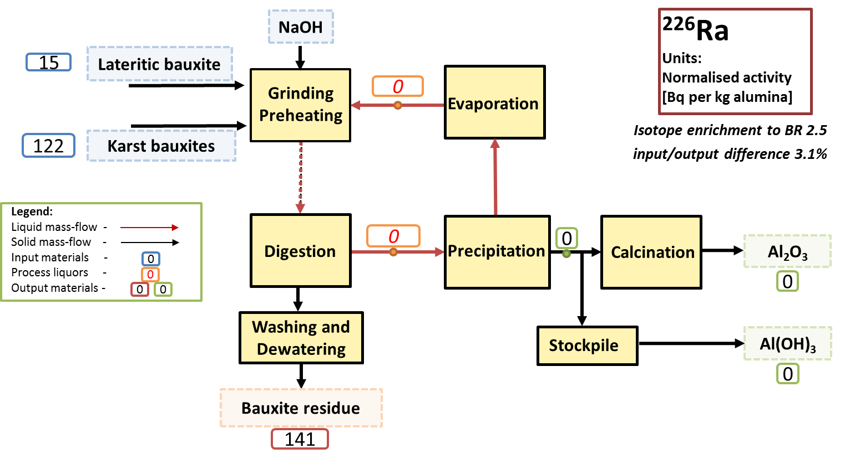
Figure 2: ²²⁶Ra (product from uranium decay series) mass flow through the Bayer process.
Figures 3 and 4 show the ²²⁸Ra and ²²⁸Th, decay products of ²³²Th. Thorium and its decay products are roughly 3 times more abundant than uranium in bauxites used in the current process. The studied isotopes of thorium decay chain behave identically — none of these isotopes were dissolved in the process liquors. Similarly, to ²²⁶Ra, these radionuclides were not detected in alumina, and ended up in BR. It should be mentioned here, that three radionuclides (²²⁸Ra, ²²⁸Th and ²²⁶Ra) have considerably lower detection limits (several times lower), than ²³⁸U, which was observed in the liquors and in alumina.
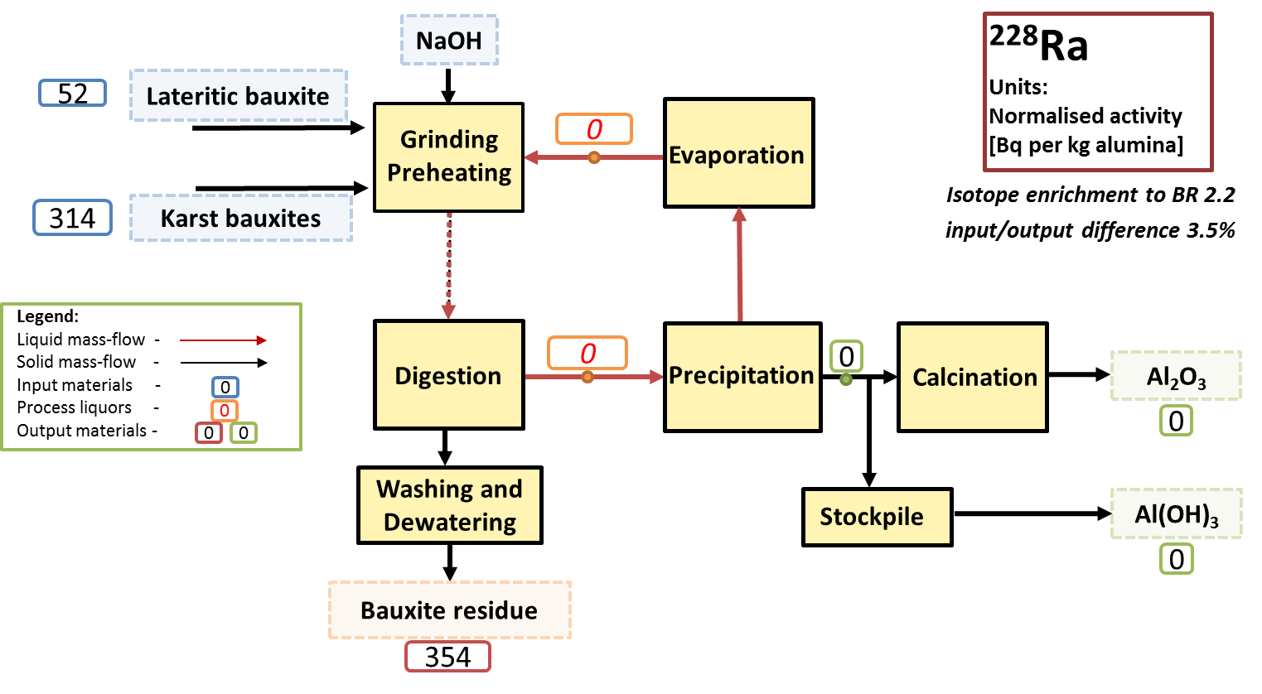
Figure 3: ²²⁸Ra (product from thorium decay series) mass flow through Bayer process.
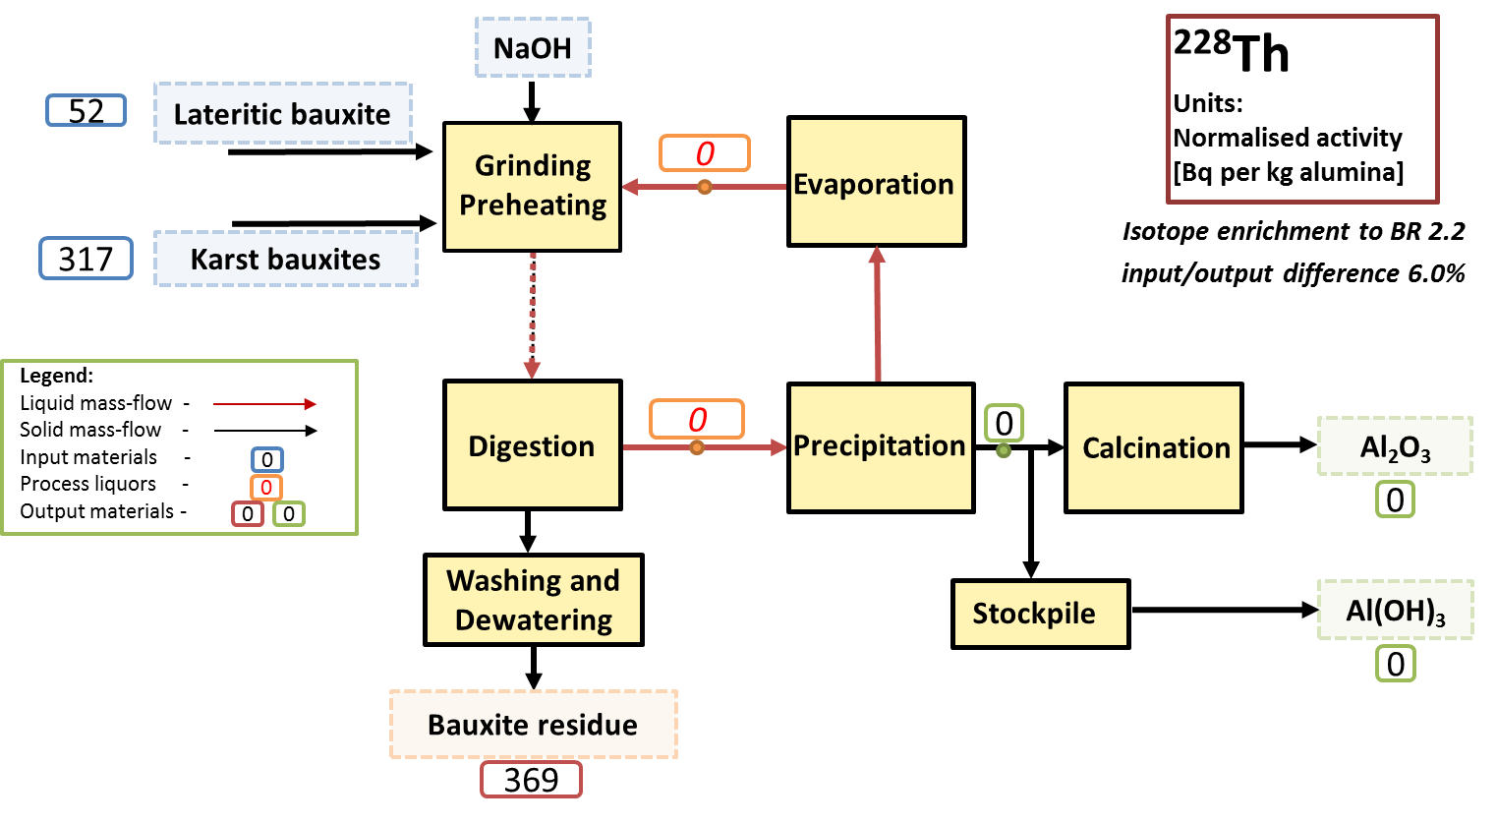
Figure 4: ²²⁸Th (product from thorium decay series) mass flow through the Bayer process.
Finally, results for ⁴⁰K are presented in Figure 5. Accumulation of ⁴⁰K was observed in the process liquors, while nothing was found in the alumina. It has been outlined earlier that potassium has the necessary chemical properties for accumulating in the Bayer liquor⁵. This isotope enrichment ratio to BR is only 1.6, meaning a portion of it is being lost. This might also be attributed to significant uncertainties in the measurements of ⁴⁰K.
In Figure 1, the uranium concentration in liquor coming from the digester drops considerably after precipitation and evaporation stages, indicating that a portion of this radionuclide might end up in aluminium hydroxide, which was later supported by measurements of hydrated and calcined alumina. For potassium, this change is below 2% supporting our observation that the isotope is retained in the process liquor and does not reach alumina.

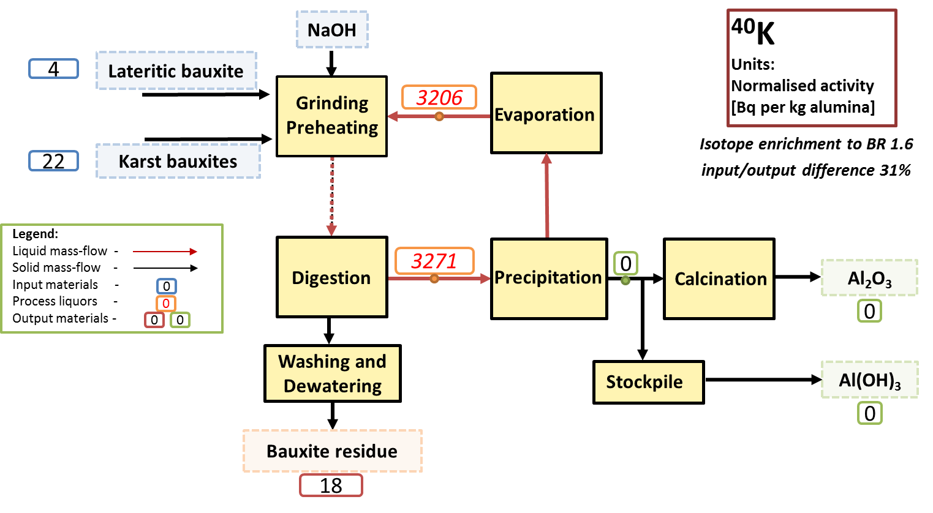
Figure 5: ⁴⁰K mass flow through the Bayer process.

Summary
Comparison between different bauxites show significantly higher radionuclide concentrations in specific karstic bauxites (from Greece and Turkey) compared to specific lateritic one (from Brazil), namely 2.4 times higher for uranium and 1.6 times for thorium. Potassium is present in trace amounts in the analysed bauxites (<10 Bq/kg), except for one bauxite type originating from Turkey, where 103.2 Bq/kg of ⁴⁰K was observed.
Most of the radionuclides end up in the bauxite residue. A minor portion of ²³⁸U is observed in alumina (3% of the amount present in bauxites, which is supported by previous research results), while its long-lived decay product ²²⁶Ra has a different fate and accumulates entirely in BR.
According to the European Basic Safety Standard (BSS)⁶, materials containing ²³⁸U and ²³²Th (and their decay products) below 1 kBq/kg as well as ⁴⁰K below 10 kBq/kg are exempt from any radiological characterization as they are unlikely to cause increased radiological exposure. Radionuclide concentrations in the studied process remains well below the legislative limits.
High potassium values in the process liquors in the Figure 5 are explained by the fact that the radionuclide is presented per material mass-flow (see eq. 1), and not the activity concentration in samples. The actual potassium content in the measured samples remained at least an order of magnitude below the limit set in the BSS.

Acknowledgements
The research leading to these results has received funding from the European Community’s Horizon 2020 Programme ([H2020/2014–2019]) under Grant Agreement no. 636876 (MSCA-ETN REDMUD). This publication reflects only the authors’ view, exempting the Community from any liability. Project website: http://www.etn.redmud.org.

References
- L. A. D. Chin, “The state-of-the-art in Bayer process technology,” Light Met. 1988, pp. 49–53, 1988.
- T. Vidmar, “EFFTRAN—A Monte Carlo efficiency transfer code for gamma-ray spectrometry,” Nucl. Instruments Methods Phys. Res. Sect. A Accel. Spectrometers, Detect. Assoc. Equip., vol. 550, no. 3, pp. 603–608, Sep. 2005.
- C. Sato, S. Kazama, A. Sakamoto, and K. Hirayanagi, “Behavior of Radioactive Elements (Uranium and Thorium) in Bayer Process,” in Essential Readings in Light Metals: Alumina and Bauxite, Volume 1, 2013, pp. 191–197.
- J. a S. Adams and K. a Richardson, “Radioactivity of Aluminum Metal,” Econ. Geol., vol. 55, pp. 1060–1063, 1960.
- M. Authier-Martin, G. Forte, S. Ostap, and J. See, “The mineralogy of bauxite for producing smelter-grade alumina,” JOM, vol. 53, no. 12, pp. 36–40, Dec. 2001.
- European Parliament, “Council Directive 2013/59/Euratom of 5 December 2013 laying down basic safety standards for protection against the dangers arising from exposure to ionising radiation, and repealing Directives 89/618/Euratom, 90/641/Euratom, 96/29/Euratom, 97/43/Euratom a,” Off J Eur Commun L13, no. December 2003, pp. 1–73, 2014.

